
Unit 4 Assessment 5 - SS Evidence Collection
Rob Johnston | TQUK Level 3 Certificate in AI Programming with Python | Unit 4 Lesson 5

Document Overview
This evidence collection supports Unit 4 Lesson 5 - Project. It demonstrates two ways to train a deep learning model, validation-set hyperparameter tuning and inference using the Iris dataset.

URL Evidence
Evidence | URL / file
Kaggle notebook | https://www.kaggle.com/code/ogwebsite/unit-4-assessment-5-deep-learning-project
GitHub folder | https://github.com/OG-Website/L3-Certificate-in-AI-Programming-with-Python/tree/main/unit-4/assessment-5-deep-learning-training-project
Iris dataset reference | https://scikit-learn.org/stable/modules/generated/sklearn.datasets.load_iris.html
Python file 1 | Unit 4 Assessment 5 - Iris Training Method 1 Baseline.py
Python file 2 | Unit 4 Assessment 5 - Iris Training Method 2 Validation Tuning Inference.py

Assessment Criteria Covered
3.1 Demonstrate ways to train the deep learning model.
3.2 Demonstrate the use of a validation set for hyperparameter tuning.
3.3 Demonstrate how to use deep learning for inference.

Screenshot 1 - Method 1 Python source
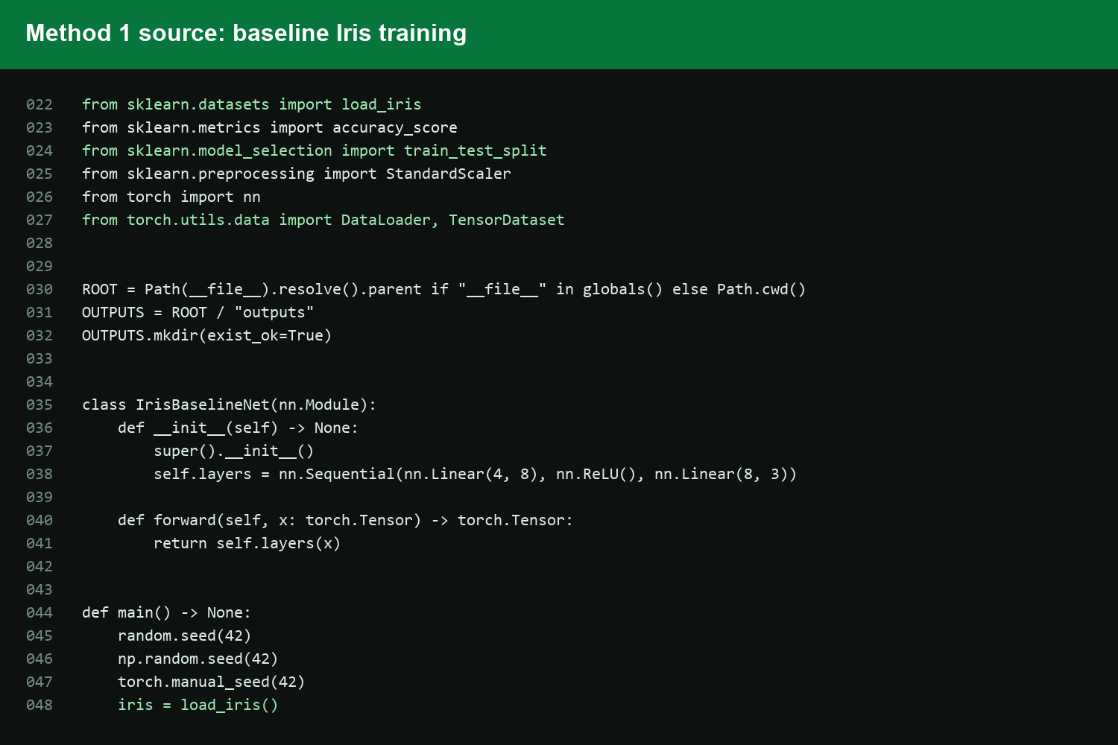
This screenshot shows the first training route for criterion 3.1. The code loads the Iris dataset, creates a train/test split, scales the features, builds a small neural network and trains it with Adam and cross-entropy loss. This proves the assessment includes a working baseline method for training a deep learning model.

Screenshot 2 - Method 1 training output
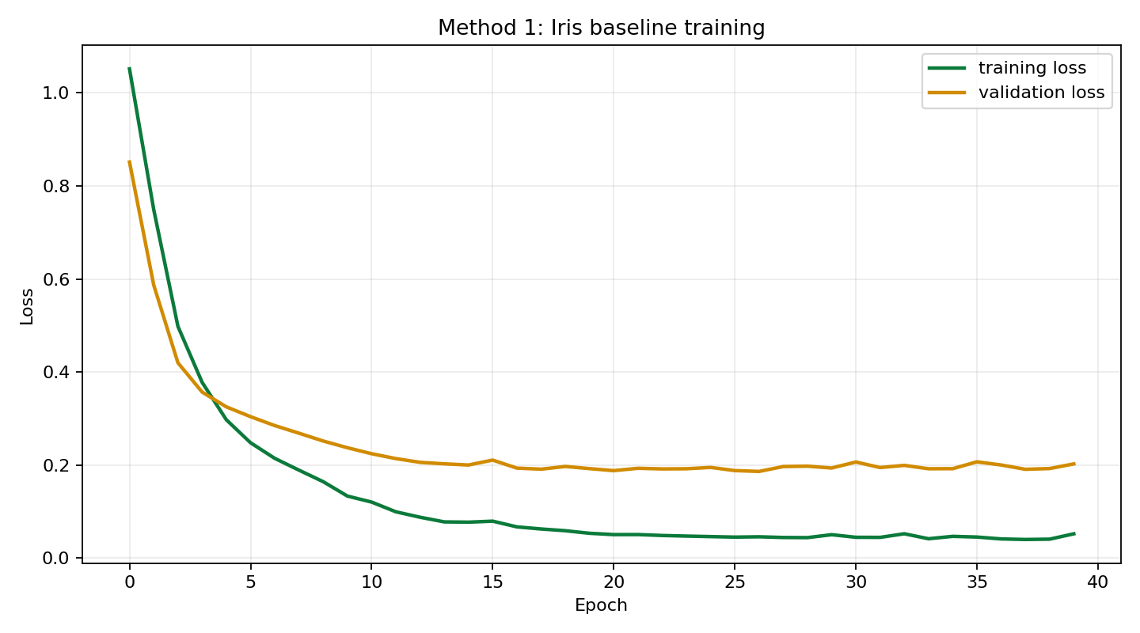
This screenshot shows the baseline training loss and validation loss during training. The baseline route achieved a test accuracy of 93.33%, which confirms the model trained successfully on the Iris dataset and produced measurable output rather than just static code.

Screenshot 3 - Method 2 validation tuning source
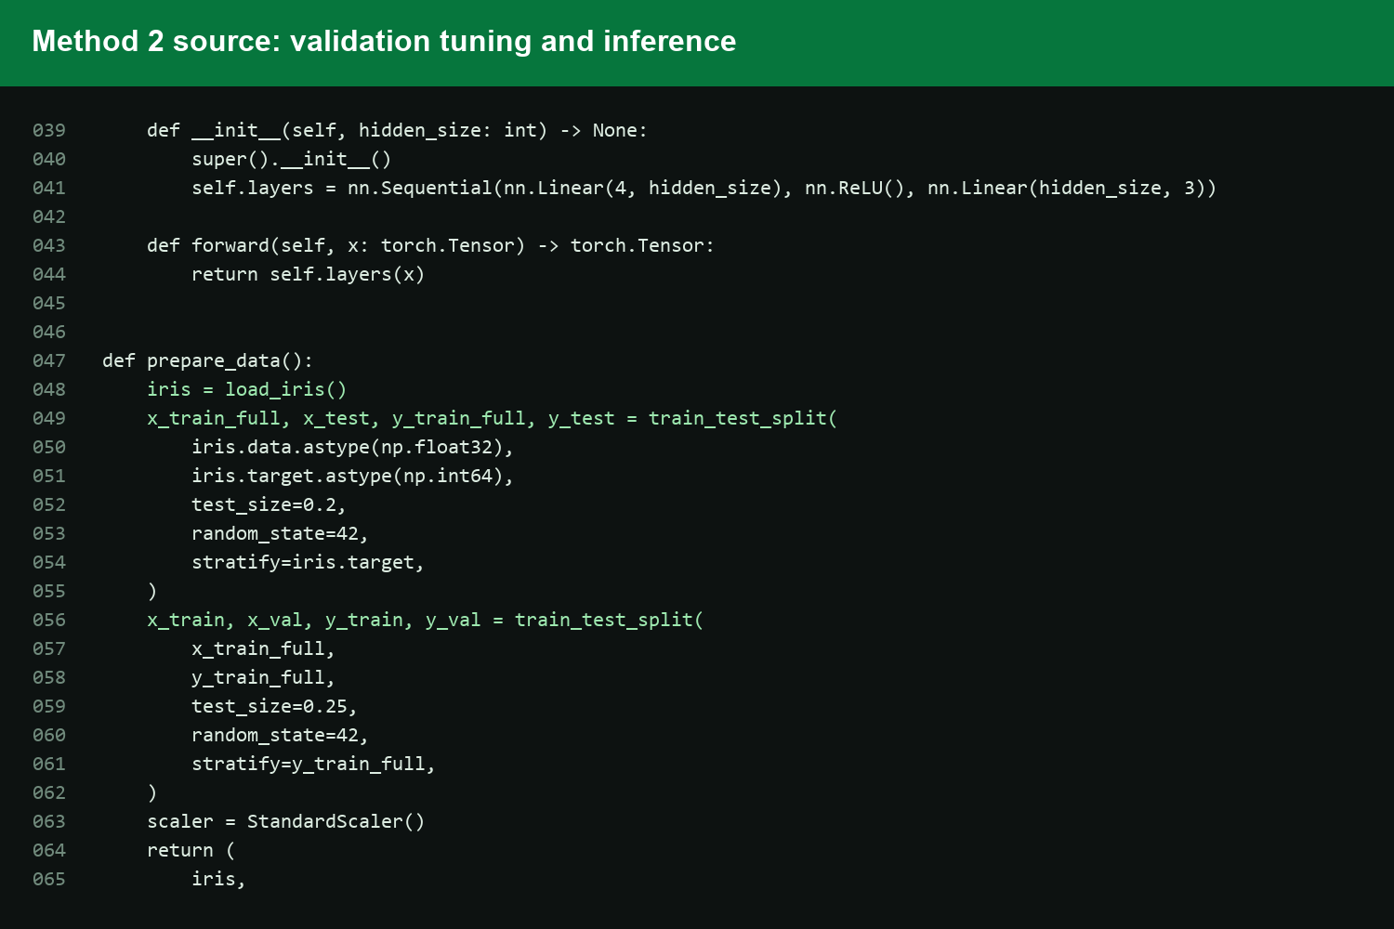
This screenshot shows the second training route. The code creates a train, validation and test split, trains different hidden-size and learning-rate configurations, and keeps the best validation result. This covers criterion 3.2 because the validation set is used to tune the model before final testing.

Screenshot 4 - Validation-set hyperparameter tuning
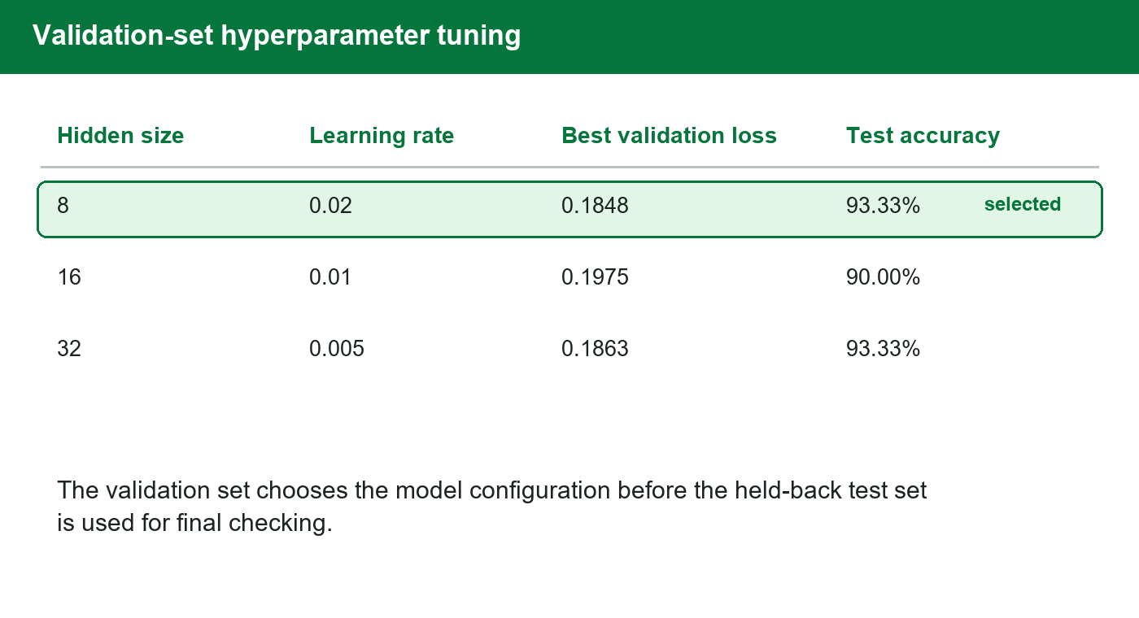
This screenshot shows the model configurations compared by validation loss. The selected model is chosen from the validation results, not from the test set. That matters because validation tuning gives a fairer workflow: training updates the weights, validation chooses the configuration, and testing checks the final model.

Screenshot 5 - Selected tuned model training
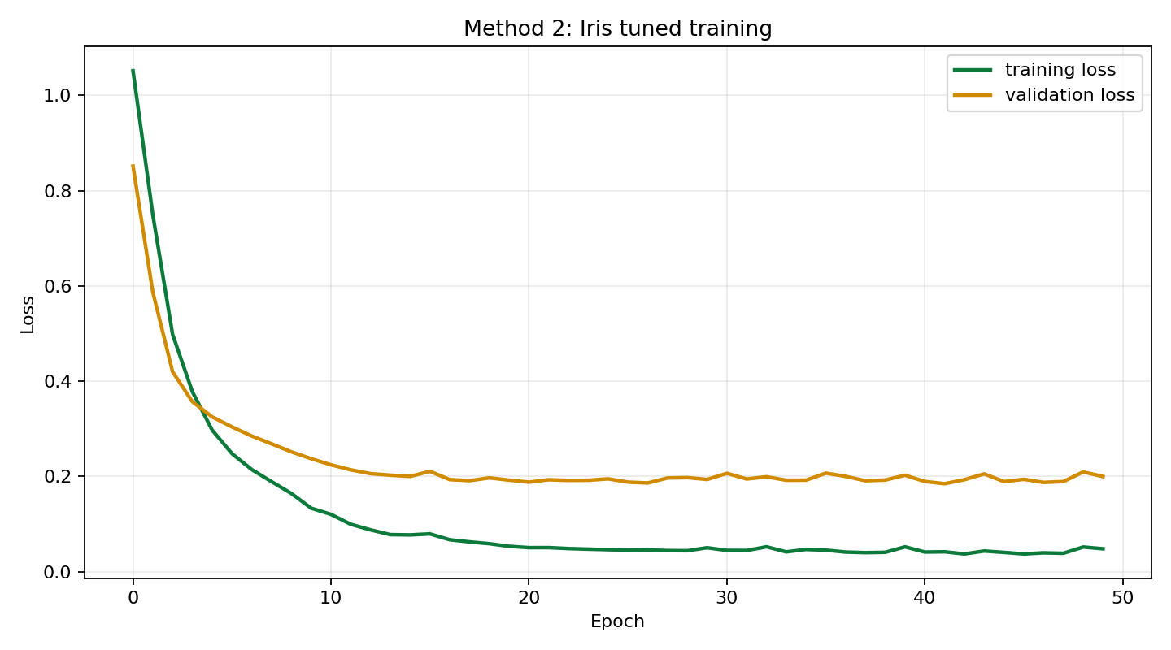
This screenshot shows the training curve for the selected tuned model. It demonstrates that the second training route is not only a different written explanation; it is a separate practical run with its own hidden size, learning rate, training loss and validation loss evidence.

Screenshot 6 - Final test checking
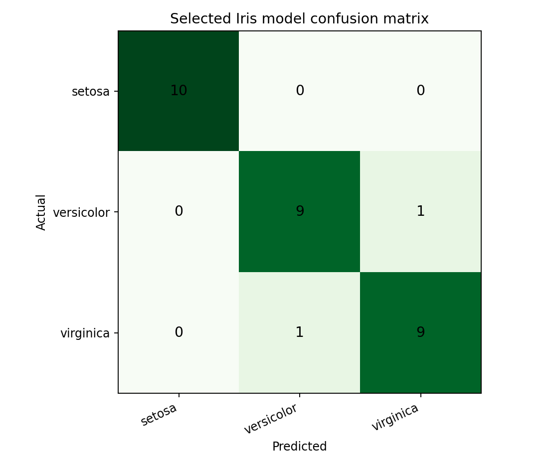
This screenshot shows the confusion matrix for the selected Iris model. It compares actual Iris classes against predicted classes on the held-back test data. This supports the final checking stage after validation tuning and shows how well the trained model performs across the class labels.

Screenshot 7 - Inference result
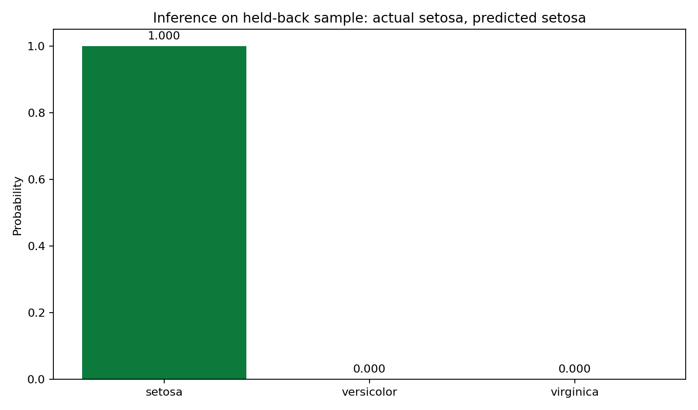
This screenshot shows inference for criterion 3.3. A held-back Iris sample is passed into the trained model, the model returns probabilities for each class, and the class with the highest probability becomes the prediction. This proves the trained model is being used after training.

Screenshot 8 - Submission links
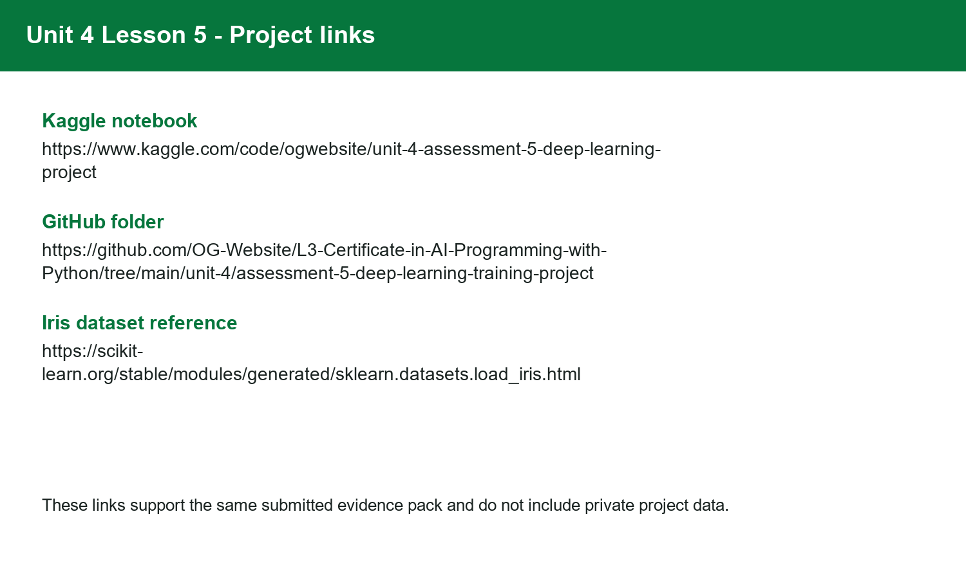
This screenshot records the live Kaggle notebook, the GitHub folder and the Iris dataset reference. These links connect the written evidence to the hosted notebook and the source files included in the submission pack.

Screenshot 9 - Video walkthrough evidence
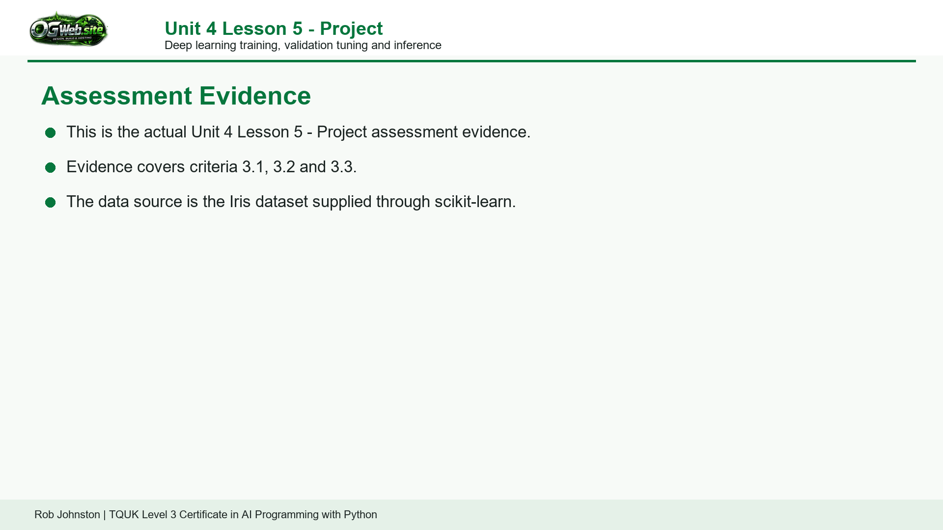
This screenshot shows the corrected video walkthrough title screen. The video is labelled as Unit 4 Lesson 5 - Project and walks through criteria 3.1, 3.2 and 3.3 using the Iris dataset, without separate-version wording.

